2017 CNYBAC Medical Device Innovation Challenge (MDIC) Graduates
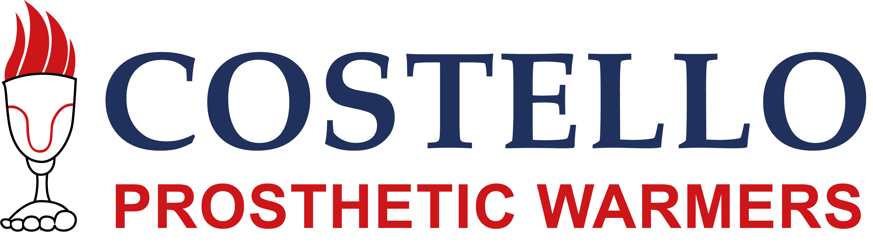  http://cpwarmers.com/  Contact: Bryan Costello bryancostello33@gmail.com | Costello Prosthetic Warmers, LLC, is a medical device startup founded by Bryan Costello, a lower leg amputee who invented its first product, the Costello Heatsleeve. The Costello Heatsleeve is based on a patented technology that applies therapeutic heat to the amputee’s stump as well as the prosthesis in order to ease pain and make the prosthesis more comfortable for the wearer. Costello Prosthetic Warmers is seeking investment and amputee connections for manufacturing and testing needs.
http://www.endoglow.com/  Contacts: Jay E. Reeder, PhD, President and COO, Paula Jaye Doyle, MD, Vice President and CMO, support@endoglow.com | EndoGlow is now a client at CNYBAC and a 2017 Medical Device Innovation Challenge graduate and recent FuzeHub Manufacturing Grant awardee with patent partner, University of Rochester. EndoGlow designs and manufactures fluorescent medical devices, Green Egg and GreenChicken (coming soon), that improve patient safety, enhance surgical efficiency, and reduce costs. The EndoGlow GreenEgg is a medical device for use during pelvic surgery to assist the surgeon in identifying anatomic features. A near-infrared fluorescent (NIRF) dye is incorporated into the device, which can be visualized through overlaying tissue using appropriate imaging systems, such as the Intuitive da Vinci Firefly.
http://onestonetech.com/  Contact: 315-217-1289 | One Stone Technology, LLC is focused on developing solutions to support sustained behavior modification to improve health and wellness. Agate, our flagship offering, is a Patient Engagement/Messaging platform that supports direct communication between patients/subscribers and their clinical team or health coach. The objective is to improve activation and outcomes by providing timely, personalized messaging that enhance an individual's knowledge, motivation and confidence to take a more active role in the management of their health.
http://www.superlativebio.com/  Contact Joe Tarsio  tarsiojf@superlativebio.com | Superlative BioSciences Corporation is seeking an investor and/or partner for the development, validation and marketing of their in vitro toxicology screening system that use human umbilical cord and placenta stem cells which would replace the need to use animals in testing. They are developing 3D culture systems representative of various normal and compromised human tissue microenvironments to meet the needs of pharmaceutical and biopharmaceutical companies in the areas of target discovery, drug efficacy testing and drug safety.
https://www.facebook.com/Simpler-Links-183181408908783/  Contact: Sherod Harris, President, Trina Skeele, Vice-President, simplelink2163@gmail.com | Simpler Links Harris Skeele Corporation, DBA, has developed a Foley Catheter Securement Device, Simpler LInks. What is unique about their product is its ability to track Dwell-Time up to seven days with the intention to prevent traumatic shearing forces on the urinary tract system and thus, increase patient comfort and reduce HAI incidents. Harris Skeele is a medical device company by nurses for nurses and are also a 2017 MDIC graduate and newly licensed client within CNYBAC. Harris Skeele will soon be conducting clinical testing of Simpler Links with the Upstate Medical University Infectious Disease Division of the Department of Medicine.

