CNY Biotech Accelerator, Upstate Medical University presents

Making Upstate Medical University an Intellectual Property Powerhouse and the Team Who Supports You!
March 8, 2023 3:00 – 4:00 p.m. EST
Register in advance for this meeting to receive meeting access instructions:
https://upstate.zoom.us/meeting/register/tJ0qcu2rrzIjG9auMIpLDe9LyQA26HPLpskW

The Industry and External Affairs (I&EA) Team serves as your technology transfer and commercialization support system. The team is focused on enabling Upstate Medical University to be the best place for innovators and entrepreneurs to solve the world’s most pressing problems. The I&EA team consists of technology and business development experts, entrepreneurs, investors, patent attorneys and agents, and marketing gurus, and more generally, a group of innovative and inquisitive problem-solvers. The team is motivated by the privilege and opportunity to serve the Upstate Medical University research community. Nothing gives the team us more pleasure than “geeking out” with innovators to learn about their research and collaborating to implement a strategy to translate into a product or service that will transform lives.
This presentation will provide an overview of all the resources and support services the I&EA team provides, including all aspects technology transfer lifecycle and new venture support services. Geek out with us on March 8th for a lively conversation focused on the following:
- What to do when you have developed new intellectual property;
- How to engage with the team to assess patentability on a new discovery;
- What happens if your intellectual property is valuable, but not patentable;
- How to disclose intellectual property;
- How our sophisticated experts in patents, commercialization, marketing and new ventures work with and for you to move your discoveries to outside-world impact;
- Receive an overview of the SUNY Technology Accelerator Fund (TAF) Program, SUNY Startup Summer School and other opportunities.

There will be plenty of time for Q&A, so please bring questions!

Meet the Speakers:

Patrick Nelson, Intellectual Property
and Business Development Associate
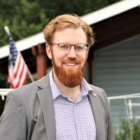

Andrew Scheinman, Licensing
and Business Development Manager
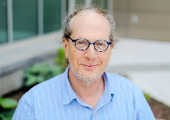

Austin Winter, Intellectual Property
and Business Development Associate

Tanya Waite, Senior Partnerships Manager

